Lesson 16
Relocatable Code

Overview
Introduction |  | Trying to use code from previous projects can be very tedious with the absolute code model discussed so far. Relocatable code helps with these issues.
In this section |  | Following is a list of topics in this section:
 | Description |  | See Page
 | Reusing Code |  | 2
 | What is relocatable code |  | 4
 | The Linking Process |  | 5
 | Assembler Directives |  | 6
 | A Simple Example |  | 8
 | Sharing Data Locations |  | 11
 | Re-using File Register Locations |  | 13
 | Libraries |  | 15
 | Using a library |  | 16
 | Further Experiments |  | 18
 | Wrap Up |  | 19

Reusing Code
Introduction | One of the very appealing things about programming the PIC is that everything is absolutely predefined. We tell the assembler precisely what to put in the PIC and where to put it. This makes PIC programming virtually devoid of the nasty surprises that we sometimes see in programming in more complex environments.  This absolute determinism has its dark side; when we want to use code from a previous project, it can become very tedious merging that old code with the new code. It would be nice if some of the hard work could be automated. That is exactly what the linker, MPLINK, does for us. However, before we can use MPLINK to help us, we need to provide clues in our code as to our intentions.
Use of include files | We have already seen how we can break larger programs apart into several files, and include those additional files in our assembly. While this can help with organizing our code, it doesn’t help with some of the challenges we have when we want to reuse the code.  If we place a group of routines we want to re-use into an include file, we can avoid cutting and pasting it into our source file. However, we need to adjust the general purpose register locations used so as not to clash with our existing program. If the include file uses names for symbols that are easy to read, we are likely to have also used those names somewhere else in the program. Finally, if we have a group of functions in a single include file, the odds are that the next program doesn’t need all of the functions. So, we must either waste the memory for those unneeded routines, or edit the include file to remove those routines. This requires studying, and re-understanding, the functions to be sure they aren’t required elsewhere.
Allocating File Register Locations | Up until now, we have used the cblock directive to identify where we want to place specific variables in the file register. Normally, we don’t really care what particular location we use, we simply don’t want to inadvertently use that location for something else. It would be nice if those locations could be allocated automatically. That way each include file could have its own declarations for general purpose register usage and somehow they could be magically merged so that they don’t conflict with the main programs or other include files.
Allocating Program Memory Locations | Program memory generally isn’t as much of a problem as GP register memory. We care about what goes into locations zero and four (reset and interrupt vectors), but beyond that we normally just use one location after another. Including some code with the include directive follows this model.  Sometimes, though, we care about keeping some program on a particular page. When we write lookup tables it is simpler to write these tables for the first 256 words of program memory. If an include file has such a table, getting that to coexist with tables in the main program, or in other include files, can get messy.
 | Continued on next page

Reusing Code, Continued
Managing Symbol Scope | Typically, if we write a routine for some particular purpose, the only program memory label¹ within that routine that needs to be known outside the routine is its entry point. However, if we include the routine through the include directive, all of the labels in the function have the same priority as the labels in the main program. We need to ensure that we don’t have name clashes with any of the labels we have already used.  The same applies to general purpose (file) register symbols. Within a routine, its memory use is generally only of concern to the routine itself. Occasionally we may pass parameters into the routine or results out of the routine with the GP registers, and these symbols would need to be known outside the function. But for the most part, general purpose register use tends to be local to a particular routine.
Reusing file register locations | On the PIC16F84A, there are only 56 general purpose register (GPR) locations. As we pointed out in the previous section, the use of these locations tends to be local to a particular function. To reuse those locations for other functions we tend to name those scratch locations with names like temp, temp1, scratch, or some other innocuous name. This makes our program harder to read since we can’t use meaningful names that might be different across routines. We could equate another symbol to that address, but now we have built ourselves a trap for when we add the next include file.

¹ To be picky, we generally refer to a label as something that we wrote in column 1 of the source. These become symbols in the assembler result for a relocatable assembly, but the “symbol” is a slightly broader term that encompasses not only our program and data labels, but also some other symbols generated by the assembler that might not be visible in our program source. For now, it is helpful to think of a symbol as simply a tag for something in the program that might need to be referenced later. It only becomes important now because when we were doing absolute assembly, there was no “later”. Now there is.

What is relocatable code
Introduction | When we assemble absolute code, the assembler generates a hex file that contains exactly the code that will be loaded into the PIC. If we want the linker to be able to move that code around, any addresses need to be somehow marked so that the linker knows to fix them up. This includes both program and GPR locations. There might even be different ways of handling different symbols.
Local and Global symbols | If we are going to be able to call a routine that wasn’t included in the current assembly, the assembler needs to be told that the routine’s name is going to be found somewhere else. Similarly, when that routine is assembled, the entry point needs to be marked so that the assembler knows that the routine’s entry point is a symbol that needs to be exposed to the outside; that is, the symbol is global. Any other symbols can be made local, which means that they are only known within the current assembly, and can’t be accessed by other routines.
Program Sections | A relocatable program is broken up into a number of program sections. These sections each contain code with different rules for where it may be placed. The section may also have a name.  Most of the time we won’t give a section a name, so the assembler will provide a name for us. By default, our program code goes into a section named .code and our data goes into a section named .udata. The assembler also provides default names of .config where the configuration data is stored (H’2007’), eedata where the EEPROM data is stored (H’2100’), and .idlocs where the ID data is stored (H’2000’). (We haven’t mentioned the ID locations but they are simply a place where we can store things like the version number of a program so we can easily identify a programmed PIC. And your author has no idea why Microchip chose to put a dot before everything except eedata.)
Assembler Output | When we assemble an absolute program, the assembler outputs a .hex file. This file contains exactly the code to be written to the PIC, in a format readable by the programming software.  When we build relocatable code, the assembler outputs a .o (object) file, which contains the assembled codes like the .hex file, but whenever an address is referenced, the file contains rules for the linker to resolve that address. The linker can then take that output, along with other .o files, and link them together to get the .hex file to load into the PIC.  Suppose, for example, we have code like:  Loop  incfsz abc,F  goto Loop  In an absolute assembly, the assembler would know the address of Loop and could then assign that address as the target of the goto. When we are generating relocatable code, however, the address of Loop is not known. Instead, the assembler outputs the offset of Loop from the front of the program section, along with instructions to the linker to add the starting address of the section to the address of Loop.

The Linking Process
Introduction | When making relocatable code, the developer has the option to break the program into any number of individual files. The programmer could choose to keep the entire program in a single file. However, it is often better to have a separate file for each subroutine in the program. Sometimes it may make sense to have several related routines in one file. The linker now has the task of linking these files together to make the final .hex file.
Linking in MPLAB | When we create a project in MPLAB, somehow MPLAB needs to know whether it should create relocatable code or absolute code. So far, we have always ended up with absolute code.  However, if we were to add more than one .asm file to the project, MPLAB² detects that we are going to have to link those files together, and would generate relocatable code. In addition, MPLAB will try to link those assemblies together. However, it does not have enough information to do this.
The Linker Script | Before the linker can piece together all the bits of our program, it needs to know what to do with the various program sections. The linker script tells the linker what to do with the program sections. The default linker script simply gives the linker a map of the hardware for the particular PIC.  The linker script takes a bit of thought. Fortunately, we can almost always steal an already prepared linker script. In the MPLAB program directory, in the subdirectory³:  MCHIP_Tools\LKR  will be found a series of linker scripts, one for each processor. We can simply add the linker script for our processor to our project under the “Linker Scripts” heading.⁴  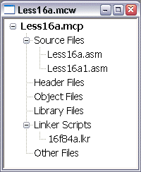  This works just like adding source files. Right-click on Linker Scripts, select Add Files…, and navigate to the linker script directory.
- This applies only to MPLAB version 6.x. In earlier versions of MPLAB, the linker must be specifically called out in the project properties. In 7.x, we must have a linker script for MPLAB to realize it must call MPLINK.
- For MPLAB 4.x, these scripts are in the install directory. In 5.x, they are in LKR under the install directory, in 7.x, they are in Microchip\MPASM Suite\LKR.
- Again, this is different for earlier versions.

Assembler Directives
Introduction | When we write a program targeted at generating relocatable code, there are a few differences in the directives we use. In this section, we will talk about the most commonly used directives.
The code directive | When we want to write instructions to be placed in the PIC’s program memory, we need to precede those instructions with a code directive:  code  Start  movlw H’01’  movwf Count  The code directive tells the assembler that the following code belongs in the program section containing instructions. Because we didn’t include a name in front of the code directive, the assembler assumes that we don’t have any special concerns about how this code is handled. If we wanted, for some reason, to group these instructions together with some instructions from another file, we could assign a name to the code segment:  MySeg code  This is generally only interesting for processors with over 2K of program memory. goto and call statements which cross 2K boundaries require an extra instruction, and a group of routines with many references between them may want to be grouped together to avoid this.  There is a special code segment named STARTUP that resides at location zero. We normally have a goto instruction there so we might do something like:  STARTUP code  goto Start  There are a few cases where we care about where a particular piece of code goes. In this case, we can assign an address to the segment:  Table2 code H’0200’  In general, this should be avoided. However, sometimes it can be used to avoid editing the linker script, which can be somewhat tricky.
The udata and res directives | What code does for instructions, udata does for GPR addresses. udata stands for uninitialized data. Up until now, we have set aside GPR locations with the cblock and cend directives. These don’t really reserve memory for us, they merely assign sequential values to symbols so that we can easily refer to them. The res directive actually reserves places in the file register for us:  udata  Var1 res 1  Var2 res 1  The value after the res indicates how many bytes to reserve. Like the code directive, we can assign a name and/or an address with the udata directive. By default, space is allocated beginning at the first available GPR location and the section is named .udata.
 | Continued on next page
Assembler Directives, Continued
global and extern | With the directives so far, we could put together a working program using relocatable code. However, the program would need to be entirely within one file, because the symbols are all local. If we try to reference something in another file, the assembler will complain that the symbol is undefined.  The global directive tells the assembler to make a symbol available outside this file.  global MySub  code  MySub xorlw H’05’  While the extern directive tells the assembler that the symbol mentioned will be resolved later by the linker:  extern MySub  code  call MySub  Both directives may list several symbols:  extern LCDinit,LCDletr,LCDclear  These directives may be placed almost anywhere, but it is best to place them near the front of the file. That way, the reader can quickly see what capabilities this file provides to the rest of the world (global) and what external assets it relies on (extern).
Additional Directives | There are quite a number of other directives which are available, but most are rarely used. Of interest when we are pressed for GPR space is the udata_ovr (overlaid data) directive which allows us to share GPR locations between program sections without sharing the symbols. The udata_shr (data shared among banks) directive forces GPR locations into the top 16 locations, which is important on PICs with more than 96 file register locations. The idata directive, in combination with the data directive, provides for initialized data.  Other than udata_ovr however, these directives aren’t commonly used, and most programs can get along with the five directives, code, udata, res, global and extern.  We will do an example with udata_ovr, even though it is a fairly uncommon directive.  The udata_shr directive is not available on the PIC16F84A because the chip doesn’t have the shared GP register hardware⁵. The idata directive is probably more complicated than it is worth, and is mostly intended to help with implementing higher level languages like Pascal. We will not cover either of these in this lesson. They are only mentioned here in because the student will see them in the assembler documentation.
⁵ On some newer PICs, especially newer 16C parts, Microchip has chosen to define the entire GPR space of the part as “share”. The GPR behavior of these parts is identical to the F84, so this can be a cause of some confusion. This treatment can be changed by editing the linker script file, but the developer is cautioned to review the datasheet carefully when using a new part.

A Simple Example
Introduction | In this section, we will make a trivial program using relocatable code. We will see how the global directive can make a label available for the extern directive.
Setting up the project | Create a project, Less16a, just like you have done many times before. However, this time, make two .asm files, Less16a.asm, and Less16a1.asm. Include both of them in your project.  Right click on “Linker Scripts” and select “Add Files…” just like you do for Source Files. (See the figure on page 5). Navigate to your MPLAB directory, and then to MCHIP_Tools and finally, LKR, and select 16f84a.lkr.⁶
Adding code to our subroutine | In Less16a1.asm, we will add the code for our subroutine. In this case, we really just want to demonstrate linking, so we really don’t need much fancy in this subroutine. Let’s just do something that complements whatever is in the W register:  global aSub  code  aSub  xorlw h'ff'  return  end  Notice that our entry point, aSub, has been made available to the rest of the world through the global directive.  We can only include the __config directive once per program, so it is best to put it in the mainline and not here. We also didn’t need anything from the processor include file. Rather than introduce an unnecessary dependency, we have omitted it here. The reader is cautioned, however, that lacking this include can produce some troublesome errors.
The mainline | Now, lets add some code to the main program, Less16a.asm, to put something into the W register, call aSub, and then store the result in the file register.  processor pic16f84a  include p16f84a.inc  __config _XT_OSC & _WDT_OFF & _PWRTE_ON  extern aSub  udata  var1 res 1  STARTUP code  goto Start  code  Start  movlw h'17'  call aSub  movwf var1  aa goto aa  end
 | Continued on next page
6 In earlier versions of MPLAB, you must highlight the .hex file in the Edit Project dialog, and click on “Node Properties”. You must then select MPLINK as the “Language Tool”. You must also provide the name of the .lkr file in the “Additional command line options”. The location of the default .lkr files is different in different versions of MPLAB other than 6.x.
A Simple Example, Continued
Assembling | When we click on the build button, notice that the assembler runs twice, once for each .asm file. Then some other programs run, including the linker. The other two programs convert the linker output to a .hex file for loading into the PIC, and also to a .cod file for simulation. These are the same files that are produced when we do an absolute assembly.  MPASM  .asm  .asm  .asm  .cod  .cod  .hex  .hex  .cof  .o  .o  MPASM  MPASM  MPLINK  MP2COD  MP2HEX  Absolute  Relocatable  .hex file for programmer  .cof “Common object format”  .o “object” file  .cod file for simulator
Simulating the program | If we choose MPLAB SIM as our simulator and step through the program, we will see that there are no nasty surprises – the program executes as we would expect, and the result gets deposited in location h’c’ in the file register, just as if we had used a cblock to define var1.
 | Continued on next page
A Simple Example, Continued
Seeing where things got placed | Go to the Project menu, and select Build Options and then Project. Select the MPLINK Linker tab in the dialog that comes up, and check the “Generate map file” check box.⁷ Now re-build the project.  Go to File->Open and in the “Files of type” dropdown select Map Files. Then open Less16a.map.  Scrolling down to “Symbols – Sorted by Address” we can see how the linker decided to place things in memory. The “Start” symbol ended up at location H’7’. The loop at “aa” ended up at h’a’. If you count instructions from Start you will see that makes sense. Since “aa” was the last location in our mainline, and “aSub” was the first location in our subroutine, aSub ends up at h’b’, right where you would expect it. The only variable in our program, “var1”, got placed at the first available file register location, h’c’.  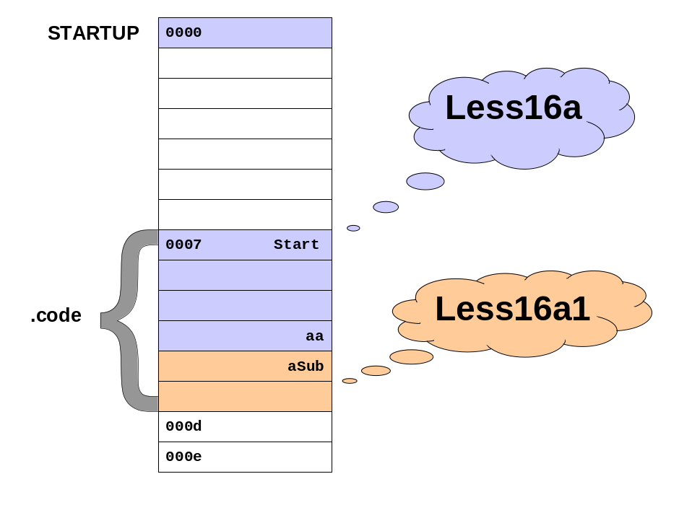  Note that the order might be different, depending on how files were added to the project, and whether you have a slightly different version of the linker. The actual order really doesn’t matter all that much since all the addresses get fixed to reflect how things really turned out.

- In earlier versions of MPLAB, you must select Edit Project from the Project menu. Then highlight the .hex file and click on “Node Properties”. Check “Map file” to cause the linker to create a map file, and in versions prior to 5, you must provide a name for the map file.

Sharing Data Locations
Introduction | In the previous example, we saw how the extern directive could tell the assembler that a symbol would be resolved elsewhere, and how the global directive could make a symbol available outside the assembly. This allows us to make subroutines which are independent of the routines that call them.  However, it is also possible for a routine to make its data global, and thus shareable with other routines. In this example, we will use a pair of routines to store and retrieve a bit of data in a location hidden from the calling program
Less16b | This time we will use a mainline and two subroutines. Again, create a project, Less16b, and add the .lkr file just like in the previous example. Our mainline will load a value into W, call a routine, then clear the W and call another routine:  processor pic16f84a  include p16f84a.inc  __config _XT_OSC & _WDT_OFF & _PWRTE_ON  extern Sub1,Sub2  STARTUP code  goto Start  code  Start  movlw h'3a'  call Sub1  clrw  call Sub2  aa goto aa  end  Notice that we will declare the two subroutines extern, just as we did with the one routine in the previous example.
The Subroutines | The first subroutine uses a file register location to save the data, much like the earlier example. However, Less16b1.asm declares that location global:  global Sub1  global Shared  udata  Shared res 1  code  Sub1  movwf Shared  return  end
 | Continued on next page
Sharing Data Locations, Continued
The Subroutines (continued) | The second subroutine, Less16b2.asm, does not declare a udata section. Instead, it declares as extern the variable made global by Less16b1.  global Sub2  extern Shared  code  Sub2  movf Shared,W  return  end
Assembling and simulating | When we assemble and link this program, it is worth looking at the map:  Symbols - Sorted by Name  Name Address Location Storage File  --------- --------- --------- ------- ---------  Start 0x000007 program static C:\Projects\PIC\Lesson16\Less16b.asm  Sub1 0x00000c program extern C:\Projects\PIC\Lesson16\Less16b1.asm  Sub2 0x00000e program extern C:\Projects\PIC\Lesson16\Less16b2.asm  aa 0x00000b program static C:\Projects\PIC\Lesson16\Less16b.asm  Shared 0x00000c data extern C:\Projects\PIC\Lesson16\Less16b1.asm  Notice that there is only one memory location reserved for the variable Shared, and it is the one declared by Less16b1. If we were to simulate this program and step through it, there would be no surprises.
Re-use | In this example, again we left off the processor and include statements from our subroutines. This actually requires a certain amount of thought. Much of the time we cannot omit the include because there are symbols in that file that we need. For example, the definitions for PORTA, INDF, and the various configurations bits are all provided by the processor include file.  However, when we are building relocatable code, it is much easier to use our routines in other programs than it is when we are building absolute code. Since different PICs are very similar, we might very well want to re-use our subroutines on a project with some other processor. As a result, we may want to avoid any unnecessary dependencies on a particular PIC model.

Re-using File Register Locations
Introduction | In the previous example, two routines shared a file register cell, because they needed to share information. However, very often, a subroutine’s file register use is temporary. Once the routine exits the memory is no longer needed. It would be handy if several subroutines could re-use the same block of memory.  This is exactly what the udata_ovr directive is for.
udata_ovr | The udata_ovr directive specifies that we are to reserve general purpose register locations, just like the udata directive. However, it allows any other routine which specifies a udata_ovr section of the same name to share these memory locations. As a result, the linker will assign all of these to the same memory location.
A udata_ovr example | In this example, we will write two delay routines, pretty much identical except that they will use different names for their loop counters. The loop counters will be stored in a udata_ovr section named Counters. The first subroutine, Less16c1.asm:  global Sub1  Counters udata_ovr  Loopc1 res 1  Loopc2 res 1  code  Sub1  movlw 5  movwf Loopc1  Loop1  movlw 3  movwf Loopc2  Loop2  decfsz Loopc2,F  goto Loop2  decfsz Loopc1,F  goto Loop1  return  end  Notice that we have a section named Counters and we have reserved two locations for our loop counters, Loopc1 and Loopc2. We have made the subroutine entry point global, just as in the previous examples.
 | Continued on next page
Re-using File Register Locations, Continued
A udata_ovr example (continued) | The second routine, Less16c2.asm, will be virtually identical, except it will have a different name, and it will use the creatively renamed loop counters, Loopc3 and Loopc4. However, the section name will be the same:  global Sub2  Counters udata_ovr  Loopc3 res 1  Loopc4 res 1  code  Sub2  movlw 5  movwf Loopc3  Loop1  movlw 3  movwf Loopc4  Loop2  decfsz Loopc4,F  goto Loop2  decfsz Loopc3,F  goto Loop1  return  end  Finally, the mainline will do nothing more than call these two subroutines over and over:  processor pic16f84a  include p16f84a.inc  __config _XT_OSC & _WDT_OFF & _PWRTE_ON  extern Sub1,Sub2  STARTUP code  goto Start  code  Start  call Sub1  call Sub2  goto Start  end
Assembling and testing | When we build this program, it is probably a little easier to use the animate feature of MPSIM to test it. But since the two subroutines don’t use their data at the same time, nothing inappropriate happens, even though, as we can see from the map, the variables share the same memory locations:  Loopc1 0x00000c data static H:\PIC\Lesson16\Less16c1.asm  Loopc2 0x00000d data static H:\PIC\Lesson16\Less16c1.asm  Loopc3 0x00000c data static H:\PIC\Lesson16\Less16c2.asm  Loopc4 0x00000d data static H:\PIC\Lesson16\Less16c2.asm
A note on udata_ovr | Notice that each subroutine’s use of the udata_ovr section must stand alone. Because a subroutine cannot know what might have happened to that memory before, it must take care to initialize every location it uses before it can count on the contents of that location.

Libraries
Introduction | So far we have seen how using relocatable code can help us break up our program into a number of pieces that are somewhat more independent than they are with absolute code. Much of the dogwork of adjusting memory locations is handled by the linker. But some of the real power of this technique becomes evident when we use a library.
What is a library? | In it’s simplest terms, a library is simply a collection of already assembled routines that haven’t yet been linked, and are stuck together all in one file. A library is a convenient way to package a group of subroutines that have something in common. For example, in the next experiment, we will use a library that contains a group of routines that manipulate the LCD.
Why a library? | As we begin to do more and more PIC projects, we discover ourselves solving the same problem over and over. The LCD is the stereotypical case. Probably half the PIC projects out there are nothing more than a PIC, an LCD, and some sort of input circuitry.  While the LCD is classic, we could see similar situations in code for the DDS, for communicating with general I2C devices, for extended precision math, for Morse generation, and on and on.  Often, handling some particular subject requires a number of routines to work in concert. The library provides a convenient way to package a group of related routines, and keep them handy to be used in future projects.
How it works | When we use a library, the linker does some special things. During linking, the linker sticks together all the object files we mention in the project, and resolves any references between them. Only then does it go looking into the library, and it retrieves only those object modules which include symbols which are unresolved.  The linker uses those modules to resolve any unresolved references from the program. However, those modules may have references to other modules. So the linker now goes back to the library (or libraries) again to find the routines needed to resolve those references. It keeps repeating this process until all the loose ends are tied up.  As a result of this, the linker will collect anything we need from the library, and nothing else.  The linker looks at the object files in the project first, then the libraries, in the order the libraries are listed in the project. This allows us to override individual library modules with our own code without modifying the library.  In the example, we will look at how all this actually happens.

Using a library
Introduction | In this section, we will do another simple program. This time, however, we will use a library to provide some other routines.
Setting up the project | Set up a Less16d project with only one source, Less16d.asm, but don’t forget to include 16f84a.lkr as you did in Less16a. Copy LCDlib.lib from the Lesson16.zip file to your project directory. Right click on Libraries in your project window, and add LCDlib.lib to the project.
The project source | This time the source will start like any other, with our processor, include, and __config directives. We are going to use two routines from the library. The first, LCDinit, initializes the LCD so it will accept commands. The second, LCDletr, displays a letter on the LCD:  extern LCDinit,LCDletr  The actual work will be done by calling LCDinit, then loading a character into the W register and calling LCDletr to display that character:  ; Initialize the LCD  call LCDinit  ; Put something on the LCD  movlw '2'  call LCDletr  We will put our tight aa goto aa at the end to prevent the program from running off into the weeds when it is done, and assemble the program and load it into the PIC-EL.
What just happened? | If you make a map and look at it, you will see that quite a few routines got included, even though we only asked for two. In fact, LCDinit calls a routine that calls a routine, and so on. We didn’t need to concern ourselves with any of this, because the linker took care of it for us.  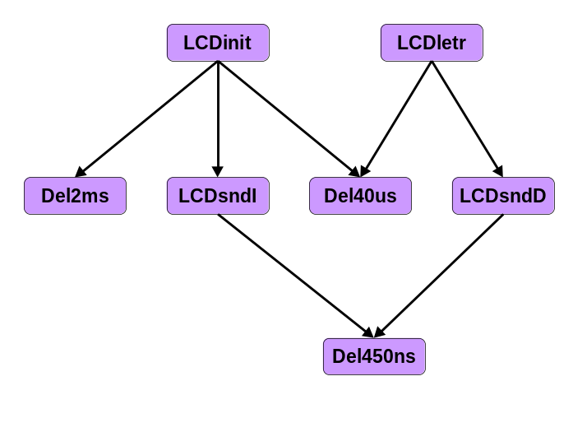
 | Continued on next page
Using a library, Continued
What just happened? (continued) | Let’s look in a little more detail at just what the linker went through.  First, it took Less16d.o, the first object file in our project. (In this case, it happens to be the only object file). Our object file defines two sections, STARTUP and .code. The linker also knows about the .cinit section that is described in the linker script. The linker always tries to put a .cinit section in there, even if we don’t need it. .cinit is always at least two words long.  Our STARTUP section must be placed at location H’0000’, so the linker places it there. The code is only one word long (which shows as two bytes on the map). However, the linker script tells the linker that locations H’0000’ through H’0004’ are reserved for STARTUP, so the first available location is H’0005’. The linker places .cinit there. This makes the next available location H’0007’ (since .cinit is two words long), so that is where the linker places .code.  Now the linker looks at the symbols. There are three symbols in the list ... Start, LCDinit, and LCDletr. The linker has just placed Start at H’0007’, so it can go back to the goto Start instruction, and assign H’0007’ as the target of the goto. We have told the linker, via the extern directive, that LCDinit and LCDletr are external, so it is content for now that it doesn’t know the targets of those two call instructions.  Now that the first object file has been processed, the linker is left with two symbols that are unresolved. It now moves on to the next object file. But in this case, there is no ‘next’ object file. Having completed all the object files, it moves on to the first library.  Looking through LCDlib, the linker discovers that the symbol LCDinit is found in the module LCDinit so it loads LCDinit next. The next available location is H’0000b’, so that is where it ends up. The linker now adds the symbols in LCDinit to its list of symbols that need to be dealt with. These include LCDsndI, Del2ms, and Del40us. (There is also a reference with no name within LCDinit, _.code_0008).  Now it looks at it’s updated symbol list to see what can be crossed off. It discovers that it can now fix up the call LCDinit instruction to call location H’000b’, so it makes that fixup and crosses LCDinit off it’s list of missing things.  Now it repeats the process of looking for things it needs in the library, next discovering Del2ms, which it places at the next available location, H’0023’.  While it is doing this, it also is doing the same thing with data locations. It turns out that Del2ms and Del40us need two general purpose register locations each, and LCDinit, LCDsend, and LCDletr need one location each, which happen to be shared (H’10 in the GPRs).  If all the possibilities in LCDlib were exhausted and there were still unresolved names, the linker would now move on to the next library. But in this case, there is only one library, and all the loose ends are tied up, so the linker can call it a day.

Further Experiments
Introduction | We have used two routines from the twenty that make up the LCDlib library. The student may want to explore some of the other routines.
LCDlib.inc | Included with the sources is an include file, LCDlib.inc. This file contains extern directives for the routines in the library. For the most part, the names of the routines are self-explanatory. The student may want to explore some of these routines.
LCDdig | On the map for Less16d, the routine LCDdig showed up, even though it wasn’t called. LCDdig is actually another entry point in LCDletr. The ASCII representation for the digits 0 through 9 is actually the digit, plus a H’30’. Were we to call LCDletr with a H’6’, for example, instead of seeing the digit 6, we would see a special character. LCDdig simply adds H’30’ to the W register and falls through to LCDletr.
LCDaddr | LCDaddr allows the caller to position the next character to be displayed. Thus, if one were to place a 4 in the W register and call LCDaddr, then a call to LCDletr would cause the character to be placed at the fifth character position on the display (the addresses start at zero).  For those PIC-EL’s with the 8 character display, this works as expected. However, the “16 character” display on some PIC-EL’s is actually a 2 line by 8 character display, so characters won’t show up on the right half of the display. If you look at LCDmacs.inc in the library source zip you will get some clues as to how to write to the second line of the display.
Del1s | When you are experimenting, it is handy to slow things down so you can see what is displayed. Del1s simply waits around for about a second so you can see what is on the display.
LCDmsg | LCDmsg is a tricky one, but useful. If you prepare a buffer in the file register that contains ASCII text, preceded by a length, place the address of that buffer into the W register, and then call LCDmsg, the message will be displayed. This routine handles the 8/16 character display issues.
Other Routines | There are a number of other interesting routines in the library. Most have relatively obvious names. If simply guessing how they work doesn’t end up with good results, the sources are included for your study.

Wrap Up
Summary | In this lesson, we have examined how create relocatable code, and how we can use it to make it easier to re-use code that we have written. We have used a library, and were able to perform relatively complex operations while writing very little code, by taking code from a library.
Coming Up | In the next lesson, we will study the LCD and see how the routines in the LCD library were developed.

